Overview of Spring Boot
Spring Boot is an open-source framework built on top of the Spring Framework, designed to simplify the development of Spring-based applications. It aims to reduce boilerplate code and configuration, enabling developers to build standalone, production-ready applications quickly and efficiently.
Key Features and Concepts:
- Convention over Configuration:
Spring Boot emphasizes sensible defaults and automatic configuration based on the project's dependencies and classpath, minimizing the need for manual setup.
- Auto-configuration:
It intelligently configures the application based on the libraries present, such as setting up a database connection if a database driver is detected.
- Starter Dependencies:
Spring Boot provides "starter" dependencies (e.g., spring-boot-starter-web, spring-boot-starter-data-jpa) that bundle commonly used libraries and their configurations, simplifying dependency management.
- Embedded Servers:
It includes embedded servers like Tomcat, Jetty, or Undertow, allowing applications to be packaged as self-contained executable JARs, eliminating the need for external server deployment.
- Production-Ready Features:
Spring Boot offers features for monitoring, health checks, metrics, and externalized configuration, making applications ready for production environments.
- Microservice Development:
It is widely used for building microservices due to its ease of development, embedded server support, and focus on independent, deployable units.
- Spring Initializr:
A web-based tool (start.spring.io) that helps developers quickly bootstrap new Spring Boot projects by selecting dependencies, build tools (Maven/Gradle), and language (Java/Kotlin/Groovy).

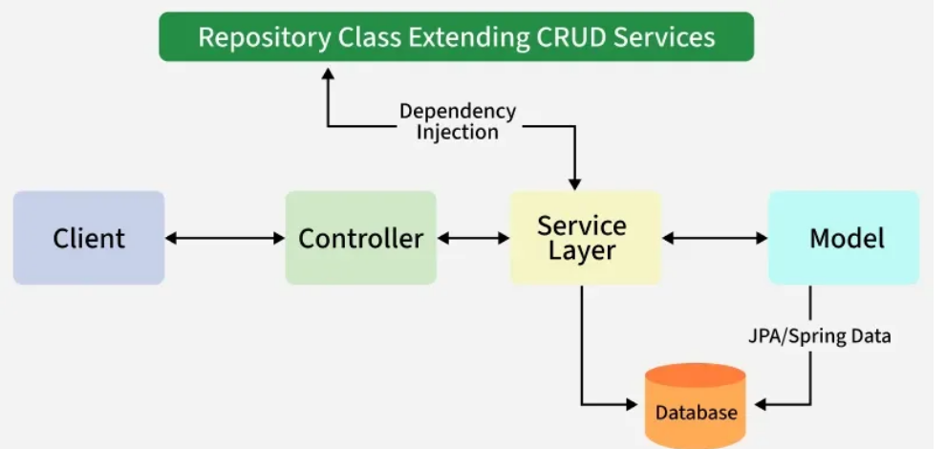

1. Client Layer
- This represents the external system or user that interacts with the application by sending HTTPS requests.
2. Controller Layer (Presentation Layer)
- Handles incoming HTTP requests from the client.
- Processes the request and sends a response.
- Delegates business logic processing to the Service Layer.
3. Service Layer (Business Logic Layer)
- Contains business logic and service classes.
- Communicates with the Repository Layer(DB) to fetch or update data.
- Uses Dependency Injection to get required repository services.
4. Repository Layer (Data Access Layer)
- Handles CRUD (Create, Read, Update, Delete) operations on the database.
- Extends Spring Data JPA or other persistence mechanisms.
5. Model Layer (Entity Layer)
- Represents database entities and domain models.
- Maps to tables in the database using JPA/Spring Data.
6. Database Layer
- The actual database that stores application data.
- Spring Boot interacts with it through JPA/Spring Data.
Request Flow in Spring Boot
Client ->Controller ->Service ->Repository ->Database ->Response
- A Client makes an HTTPS request (GET/POST/PUT/DELETE).
- The request is handled by the Controller, which is mapped to the corresponding route.
- If business logic is required, the Controller calls the Service Layer.
- The Service Layer processes the logic and interacts with the Repository Layer to retrieve or modify data in the Database.
- The data is mapped using JPA with the corresponding Model/Entity class.
- The response is sent back to the client. If using Spring MVC with JSP, a JSP page may be returned as the response if no errors occur.

Auto-Configuration
Spring Boot is heavily attracting developers toward it because of three main features as follows:
- Auto-configuration - such as checking for the dependencies, the presence of certain classes in the classpath, the existence of a bean, or the activation of some property.
- An opinionated approach to configuration.
- The ability to create stand-alone applications.
Auto-Configuration in Spring Boot
- @Conditional annotation acts as a base for the Spring Boot auto-configuration annotation extensions.
- It automatically registers the beans with @Component, @Configuration, @Bean, and meta-annotations for building custom stereotype annotations, etc.
- The annotation @EnableAutoConfiguration is used to enable the auto-configuration feature.
- The @EnableAutoConfiguration annotation enables the auto-configuration of Spring ApplicationContext by scanning the classpath components and registering the beans.
- This annotation is wrapped inside the @SpringBootApplication annotation along with @ComponentScan and @SpringBootConfiguration annotations.
- When running main() method, this annotation initiates auto-configuration.

Note: You should use the '@EnableAutoConfiguration' annotation only one time in your application.
- 'spring-boot-autoconfigure.jar' is the file that looks after all the auto-configuration.
- All auto-configuration logic for MVC, data, JMS, and other frameworks is present in a single jar

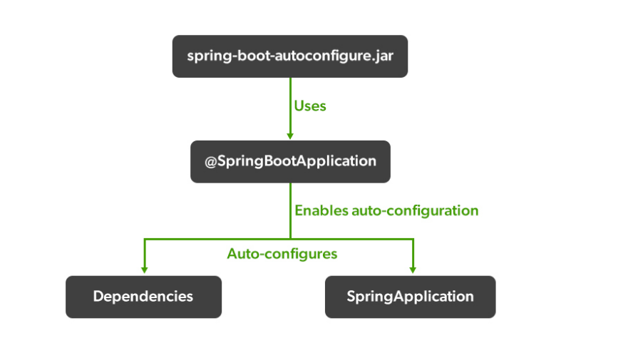
Overview of Common Spring Boot Starters (Web, Data JPA)
Spring Boot Starters are a set of convenient dependency descriptors that allow for quick and easy setup of Spring Boot applications. They bundle together common dependencies required for a specific type of application, reducing the need to manually manage individual library versions and configurations.
1. spring-boot-starter-web
- Purpose:
This starter is used for building web applications, including RESTful APIs, using Spring MVC.
- Key Dependencies:
It includes embedded servers like Tomcat (default), Jetty, or Undertow, along with Spring MVC, Jackson (for JSON processing), and other related web development libraries.
- Functionality:
  - Provides automatic configuration for web applications.
  - Enables the creation of REST controllers using annotations like @RestController, @RequestMapping, etc.
  - Simplifies the setup of an embedded server, allowing for easy deployment and execution of web applications.
2. spring-boot-starter-data-jpa
- Purpose:
This starter simplifies the implementation of data access layers using Spring Data JPA and the Java Persistence API (JPA).
- Key Dependencies:
It includes Spring Data JPA, Hibernate (as the default JPA implementation), and a database connection pool (e.g., HikariCP).
- Functionality:
  - Reduces boilerplate code required for data access by providing repository interfaces (e.g., JpaRepository).
  - Enables automatic generation of CRUD (Create, Read, Update, Delete) methods based on method names in repository interfaces.
  - Facilitates object-relational mapping (ORM) with JPA, allowing Java objects to be mapped to database tables.
  - Supports advanced querying options through derived query methods, @Query annotations, and JPA Specifications.
In Summary:
- spring-boot-starter-web
focuses on the presentation layer and handling HTTP requests and responses for web applications.
- spring-boot-starter-data-jpa
focuses on the persistence layer and simplifying interaction with relational databases through JPA.
These two starters are frequently used together in Spring Boot applications to create full-stack web applications that interact with a database.

Spring Boot Tools
Project Lombok is a Java library that helps reduce boilerplate code in Spring Boot applications by automatically generating common methods like getters, setters, constructors, equals(), hashCode(), and toString() during the compilation phase. It achieves this through annotation processing, which hooks into the compile process and generates source code before actual compilation.
Integrating Lombok in a Spring Boot project:
- Add the Lombok dependency: Include the Lombok dependency in your project's build file (e.g., pom.xml for Maven or build.gradle for Gradle). Ensure you include both compileOnly and annotationProcessor configurations.
Code
<!-- Maven (pom.xml) -->
<dependency>
<groupId>org.projectlombok</groupId>
<artifactId>lombok</artifactId>
<version>1.18.30</version> <!-- Use the latest stable version -->
<scope>provided</scope>
</dependency>
- Install IDE Plugin (if necessary):
For certain IDEs like IntelliJ IDEA, you might need to install a Lombok plugin and enable annotation processing in your IDE settings to ensure proper functionality and code highlighting.
- Use Lombok Annotations:
Apply Lombok annotations to your Java classes to generate the desired boilerplate code. Common annotations include:
  - @Data: Generates getters, setters, equals(), hashCode(), and toString().
  - @Getter, @Setter: Generates specific getter and setter methods for fields.
  - @NoArgsConstructor, @AllArgsConstructor: Generates no-argument and all-argument constructors, respectively.
  - @Builder: Facilitates the creation of builder patterns for object construction.
Example:
Java
import lombok.Data;
import lombok.NoArgsConstructor;
import lombok.AllArgsConstructor;
@Data
@NoArgsConstructor
@AllArgsConstructor
public class Employee {
private Long id;
private String name;
private String department;
}
This Employee class, with Lombok annotations, will automatically have getters, setters, equals(), hashCode(), toString(), a no-argument constructor, and an all-argument constructor generated at compile time, eliminating the need to write them manually.

Devtools
Spring Boot DevTools is a module designed to enhance the developer experience when building Spring Boot applications. It provides a set of features that aim to automate repetitive tasks and improve the development iteration cycle.
Key Features of Spring Boot DevTools:
- Automatic Restart:
DevTools automatically detects changes in class files, resources, and configuration, and triggers a restart of the application. This eliminates the need for manual restarts after code modifications, significantly speeding up the development feedback loop.
- Live Reload:
For web applications, DevTools can automatically trigger a browser refresh when static resources (like HTML, CSS, JavaScript) are modified, allowing developers to see changes instantly without manual browser reloading.
- Property Overrides:
Certain application properties that are beneficial during development (e.g., disabling caching, enabling detailed debugging) can be automatically overridden by DevTools, simplifying configuration for the development environment.
- Remote Debugging Support:
DevTools facilitates remote debugging of applications running on a remote server, offering a streamlined approach to troubleshooting issues in deployed environments.
How to Include DevTools:
To incorporate DevTools into a Spring Boot project, the spring-boot-devtools dependency needs to be added to the project's build file (e.g., pom.xml for Maven or build.gradle for Gradle).
Example (Maven):
Code
<dependencies>
<dependency>
<groupId>org.springframework.boot</groupId>
<artifactId>spring-boot-devtools</artifactId>
<optional>true</optional>
</dependency>
</dependencies>
After adding the dependency and rebuilding the project, Spring Boot DevTools will be active and provide its development-enhancing features.

Spring Environments
Spring Boot's "Environment" refers to an abstraction that encapsulates two key aspects of an application's operating context: profiles and properties. This abstraction allows for flexible configuration and adaptation of an application to different deployment scenarios (e.g., development, testing, production).
1. Profiles:
- Definition:
Profiles are named, logical groups of bean definitions and configurations that are conditionally activated. This means certain beans or configuration settings will only be registered and used if a specific profile is active.
- Purpose:
Profiles allow you to define environment-specific configurations without altering the core application code. For example, you can have a "dev" profile that uses an in-memory database and a "prod" profile that connects to a persistent, external database.
- Activation:
Profiles can be activated in several ways:
  - Spring Boot application.properties/application.yml: Using spring.profiles.active=profileName.
  - Environment variables: SPRING_PROFILES_ACTIVE=profileName.
  - JVM System properties: -Dspring.profiles.active=profileName.
  - Programmatically: Using SpringApplication.setAdditionalProfiles().
- Default Profile:
If no profile is explicitly activated, the "default" profile is used. You can customize its name using spring.profiles.default.
2. Properties:
- Definition:
Properties are key-value pairs that configure various aspects of the application, such as server port, database credentials, or custom application settings.
- Sources:
Spring Boot supports a wide range of externalized configuration sources for properties, including:
  - application.properties or application.yml files (and their profile-specific variants like application-dev.properties).
  - Environment variables.
  - JVM System properties.
  - Command-line arguments.
  - JNDI properties.
- Accessing Properties:
  - @Value annotation: Inject individual property values directly into fields.
  - @ConfigurationProperties: Bind sets of related properties to structured Java objects.
  - Environment interface: Programmatically access properties and active profiles from the Environment bean.
- PropertySource Order:
Spring Boot has a specific order of precedence for property sources, allowing later sources to override values defined in earlier ones. This ensures that more specific, environment-level configurations can override general defaults.

Overview of Spring MVC & Architecture
Spring MVC Explained: Architecture & Request Flow Diagram | Coding Shuttle

